Name | Soham Joshi
Roll no | 24204C0021
Batch | 1
Subject name | Python Programming & Data Structure
Teacher Name | Ms. Rasika Patil

Experiments | 13
Title | *Implement sorting techniques using python  a) Bubble Sort  b) Selection Sort  c) Insertion Sort

Programming Questions with Answer
1 | Program for Bubble Sort  arr = [64, 34, 25, 12, 22, 11, 90]
SCRIPT | 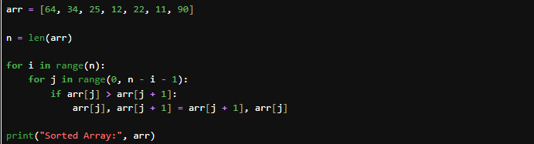
OP
2 | Program for Selection Sort  arr = [64, 25, 20,10,30,12, 22, 11]
SCRIPT | 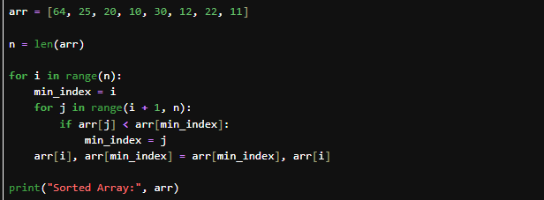
OP
3 | Program for Insertion Sort  arr = [12, 11, 13, 5, 70,56,71,85,6]
SCRIPT | 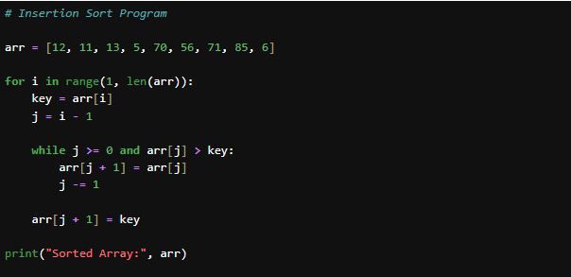
OP | 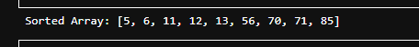
Debugging Questions with Corrected Answers
1 | Debug the following code  Wrong code:  for i in len(arr):  for j in len(arr)-1:  if arr[j] > arr[j+1]:  swap(arr[j], arr[j+1])
OP | Error: TypeError: 'int' object is not iterable  Correct code: for i in range(len(arr)):  for j in range(len(arr) - 1):  if arr[j] > arr[j + 1]:  arr[j], arr[j + 1] = arr[j + 1], arr[j]
2 | Debug the following code  Wrong code:  for i in range(1, arr):  key = arr[i]
OP | Error: TypeError: 'list' object cannot be interpreted as an integer  Correct code: for i in range(1, len(arr)):  key = arr[i]
Conclusion

Performance Indicators |  | Teachers Dated and Signature
Process Related  (15 M) | Product Related  (10 M) | Total (25 M)

